Learner Demographics and Course Enrollment Behavior Analysis on EduPro
Author
Rohit Satre
Department of CSE-AIDS

- Abstract
Online learning platforms have significantly transformed the educational landscape by providing flexible and accessible learning opportunities to individuals across diverse demographic backgrounds. Understanding learner characteristics and enrollment behavior is essential for designing effective educational strategies and improving learner engagement. This study presents an analysis of learner demographics and course enrollment behavior on the EduPro online learning platform using descriptive analytics techniques.
To understand how people learn, we need to look at the information we have about the users, the courses they take, and the transactions they make. We want to find out things like how old people are, if there are more men or women, what kinds of courses they like, and when they sign up for classes. First, we had to clean up the data by filling in missing pieces, getting rid of duplicates, and making sure everything was in a format we could use. Then, we used different ways to visualize the data, like bar charts, pie charts, and special heatmaps that can even move in 3D. This helped us see how learners behave and find patterns we might not have noticed otherwise. By doing this, we can get a better idea of what people like and how they learn, which can help us make better courses for them.
We also created a special tool using Streamlit that helps people look at student enrollment and demographic information in a more interactive way. This study gives useful ideas to people who plan education and those who manage online platforms, so they can make courses more interesting, get more students involved, and create a more welcoming online space for everyone.
- Keywords: Online Learning Analytics, Educational Data Mining, Demographic Analysis, Enrollment Behavior, Streamlit Dashboard, Data Visualization.
- Introduction
  - Background
The rapid advancement of internet technologies has led to substantial growth in online learning platforms. These platforms provide learners with the flexibility to access educational resources regardless of geographical boundaries, enabling individuals to pursue academic enrichment, professional development, and lifelong learning opportunities.
As more and more people turn to online learning, schools and websites that offer courses are collecting a lot of information about their students and how they use the site. This data is really useful because it tells us about the kinds of people who are learning, what they like, and how they interact with the material. By looking closely at this information, we can make informed decisions and create better learning experiences for everyone. This can help make online education more effective and enjoyable.
Despite the availability of learner data, many online platforms struggle to convert raw information into actionable insights. Understanding who the learners are, what courses they prefer, and how different demographic groups interact with educational content remains a significant challenge. Addressing these challenges requires the application of descriptive analytics techniques that transform data into meaningful knowledge.
1.2 Problem Statement
Educational planners and platform administrators often lack a comprehensive understanding of learner characteristics and enrollment patterns. Without such insights, it becomes difficult to design relevant courses, allocate resources efficiently, and ensure equitable access to learning opportunities.
The EduPro platform records substantial amounts of user, course, and transaction data. However, these datasets remain underutilized unless systematic analytical approaches are employed. Therefore, there is a need to analyze learner demographics and enrollment behavior to uncover meaningful trends that can support educational planning and learner engagement strategies.
1.3 Objectives of the Study
The primary objectives of this study are:
- To analyze the demographic characteristics of EduPro learners.
- We want to find out how different age groups and genders are signing up for things, so we can see what's popular and what's not.
- To determine the most popular course categories and course levels.
- To investigate relationships between demographic factors and course preferences.
- To assess inclusivity in learner participation.
- To develop an interactive Streamlit dashboard for dynamic exploration of findings.
- To help make informed decisions about education by using data to guide the planning process.

1.4 Scope of the Study
This research looks at the details of the data from the EduPro online learning platform. It checks the information about the users, the courses they take, and the transactions they make. The goal is to find patterns and trends that happened in the past, using the data that is available.
Predictive modeling and recommendation systems are beyond the scope of the present study. However, the findings provide a strong foundation for future research involving advanced analytics and machine learning applications in online education.
1.5 Significance of the Study
This study helps many people involved in education. Schools can use the results to create courses that focus on the students and make better use of their resources. The people in charge of online platforms can use the findings to keep users engaged by giving them what they need and want. Leaders who make education policies can use the insights to make sure everyone has equal access to education and to make decisions based on facts.
Moreover, the study demonstrates the practical application of data analytics and visualization techniques using real-world educational datasets, highlighting the importance of transforming data into actionable intelligence.
- Literature Review
People are really taking to online learning platforms, and this has caught the attention of researchers, teachers, and those who make policies. The information we get from these platforms is super useful for understanding how learners behave, making learning better, and helping us make decisions based on facts. Here, we're looking back at studies that have already been done on things like online learning analytics, who learners are, how they enroll, digging deep into educational data, and systems that use dashboards to show us what's going on.
2.1 Online Learning and Digital Education
The way we learn is changing a lot these days. With the internet getting better and better, schools can now offer classes that aren't just limited to a physical room. This means people from all over the world can learn together, no matter where they're from. It's like the whole world is your classroom now. You can get to educational stuff from anywhere, which is really cool. This is all thanks to the internet, which has made it possible for people to learn in a more flexible way.
The growth of Massive Open Online Courses (MOOCs) and digital learning platforms has further accelerated the demand for understanding learner engagement and participation. Researchers have emphasized that online education is no longer limited to supplementary learning but has become an essential component of lifelong education and professional development.
The success of online learning really depends on knowing what learners need and want. So, researchers are now looking closely at the data that learners produce to make learning better.
2.2 Educational Data Mining and Learning Analytics
Learning from data is a big part of making education better. We use computers to look at lots of information about learning and find important trends. This helps us make good decisions about how to teach and learn. It's a field that combines education, statistics, machine learning, and data analysis to make learning better. By using data, we can find new ways to improve education and make it more effective. This approach is all about using information to make informed decisions and create a better learning experience.
Similarly, Learning Analytics focuses on the measurement, collection, analysis, and reporting of learner data with the objective of understanding and optimizing learning processes. Siemens and Long (2011) argued that learning analytics provides institutions with the ability to identify learner needs, monitor engagement, and develop targeted interventions that improve educational experiences.
Many research studies have shown that looking at data in a simple way is a crucial first step in understanding educational information. This basic approach lets researchers get a sense of who the learners are and how they are signing up for classes before trying to predict what might happen or figure out what should be done. By taking this first step, researchers can get a clear picture of what's going on, which makes it easier to make good decisions later on.
The present study aligns with these principles by employing descriptive analytical methods to explore demographic characteristics and enrollment behavior on the EduPro platform.
2.3 Learner Demographics and Enrollment Behavior
Learner demographics have been identified as important determinants of educational participation and course selection. Factors such as age, gender, educational background, and professional experience influence learning motivations and preferences.
Research conducted by Kizilcec et al. ( 2017) found that demographic characteristics significantly affect participation patterns within online learning environments. Younger learners often exhibit higher engagement with technology-based educational platforms due to greater digital familiarity, while older learners may prioritize professional development and skill enhancement.
Gender-based analyses have also revealed variations in course preferences and completion behaviors. While participation across genders has improved considerably, differences continue to exist regarding subject interests and learning objectives.
Understanding these demographic differences enables educational institutions to develop more inclusive learning environments and design courses that address the diverse needs of learners.
The EduPro study investigates these relationships by examining how different age groups and genders interact with course categories and levels.
2.4 Course Preference Analysis in Online Learning
Knowing what courses are popular can help us see what's new and what people want to learn. It also shows us what skills are in demand in the workforce. When we know what subjects are most liked, schools can use their resources better and focus on making those courses even better. This way, they can make sure they're teaching people what they really need to know.
Previous studies have reported increasing demand for technology-oriented courses, business management programs, and professional certification opportunities. Learners frequently seek educational experiences that enhance employability and support career advancement.
In 2014, Jordan pointed out that looking at how many people sign up for online courses can tell us a lot about what learners are interested in and what they expect from schools. This information can help schools create courses that people actually want to take. By paying attention to these trends, schools can make sure their courses are relevant and useful to learners.
Furthermore, analyzing enrollment behavior across demographic groups allows researchers to identify whether specific populations exhibit distinct preferences. This understanding supports the development of targeted educational initiatives.
In the context of EduPro, course category analysis contributes to identifying areas of high demand and informs recommendations for future educational planning.
2.5 Inclusivity and Equity in Digital Education
Ensuring equitable access to education remains a major objective for governments and educational organizations worldwide. Online learning platforms possess the potential to reduce barriers associated with geography, socioeconomic status, and time constraints.
Nevertheless, concerns regarding the digital divide persist. Factors such as technological accessibility, digital literacy, and socioeconomic disparities continue to influence educational participation.
UNESCO has emphasized that inclusive education requires proactive strategies to ensure that marginalized populations can benefit from technological advancements. Educational systems must therefore monitor participation patterns to identify underrepresented groups and implement interventions that promote equal opportunities.
Research has looked into how inclusive online learning spaces are by studying who is using them. It found that even though the internet makes it easier for people to access learning, some groups of people might still be left behind.
The present study contributes to this area by evaluating demographic representation and identifying opportunities to strengthen inclusivity within the EduPro platform.
2.6 Data Visualization and Dashboard-Based Decision Support
Data visualization plays a critical role in transforming analytical findings into actionable insights. Visual representations enable stakeholders to identify patterns, trends, and anomalies more efficiently than textual reports alone.
Few (2013) said that dashboards are really useful because they take complex data and turn it into something simple and easy to understand. This helps people make good decisions quickly. When you add interactive features to dashboards, it gets even better. Users can play around with the data, using filters and other tools to see what's going on, and that really gets them engaged.
Recent developments in open-source technologies have facilitated the adoption of dashboard solutions within educational contexts. Tools such as Streamlit enable rapid development of interactive analytical applications without extensive web development expertise.
Educational dashboards have been employed to monitor learner progress, evaluate institutional performance, and communicate analytical findings to policymakers. The integration of descriptive analytics with interactive visualization enhances the accessibility and usability of educational data.
We created a dashboard using Streamlit to show information about learners, like who they are and how they're doing. It also shows how many people are enrolled in different things, and it has cool heatmaps and 3D pictures that you can play with. This helps people in charge make good decisions based on facts, and it's really useful for understanding what's going on in education.
2.7 Research Gap
Although numerous studies have explored online learning analytics, several limitations remain evident within existing literature.
First, many investigations focus primarily on predictive modeling and learner performance while providing limited attention to descriptive analyses of learner demographics and enrollment behavior.
Not many research projects bring together studying population trends, checking if something is fair to all groups, and creating interactive tools to show the results in one place.
Third, there remains a need for practical case studies demonstrating how educational institutions can transform transactional learner data into actionable insights using accessible analytical tools.
The EduPro study addresses these gaps by integrating demographic analysis, enrollment behavior exploration, inclusivity evaluation, and dashboard-based visualization using descriptive analytical techniques. The findings provide practical recommendations that support educational planning and contribute to the growing body of knowledge in educational data analytics.
2.8 Summary of Literature Review
The reviewed literature highlights the growing importance of educational data analytics in understanding learner behavior and improving digital education. Previous studies demonstrate that demographic characteristics influence participation patterns and course preferences, while dashboard technologies facilitate effective communication of analytical findings.
Despite substantial progress in the field, opportunities remain to integrate descriptive analytics, inclusivity assessment, and interactive visualization within practical educational contexts. The EduPro analysis builds upon existing knowledge by providing a comprehensive examination of learner demographics and enrollment behavior through an accessible and stakeholder-oriented analytical framework.
- Dataset Description and Preprocessing
3.1 Dataset Description
The present study utilized the EduPro online learning platform dataset to investigate learner demographics and course enrollment behavior. The dataset was provided in Microsoft Excel format and consisted of multiple interconnected worksheets representing different aspects of the learning ecosystem. These datasets collectively enabled a comprehensive analysis of learners, courses, transactions, and instructors.
The following datasets were used in this study:
A. Users Dataset
The Users dataset contained demographic information related to the learners registered on the EduPro platform. This dataset formed the foundation for demographic analysis and included attributes such as age and gender.
The major variables included:
- UserID: Unique identifier assigned to each learner.
- Age: Age of the learner.
- Gender: Gender category of the learner.
Some extra details about the learners are also available in the data, such as their demographic information.
The information we got from the users helped us understand the different types of people using our system and group them by age, which was useful for our study.
B. Courses Dataset
The Courses dataset contained information regarding the educational programs available on the platform.
The key attributes included:
- CourseID: Unique identifier assigned to each course.
- Course Category: This is the subject area or category that the course falls under.
- Course Level: This is how hard the course is, like Beginner, Intermediate, or Advanced.
- CourseType: Delivery or structural classification of the course.
This dataset was used to identify popular educational domains and investigate learner preferences.
C. Transactions Dataset
The Transactions dataset recorded learner enrollment activities and served as the primary source for enrollment analysis.
The major variables included:
- TransactionID: Unique transaction identifier.
- UserID: This is a special code that connects a learner to their enrollment.
- CourseID: This is a special code that connects a student's enrollment to a specific course.
- Enrollment-related information: Details representing learner participation.
By integrating the Transactions dataset with learner and course information, enrollment patterns and behavioral trends were explored.
D. Teachers Dataset
The Teachers dataset contained information related to instructors associated with the EduPro platform.
The variables included instructor-specific details such as:
- Teacher identifiers.
- Instructor names.
- Subject expertise.
- Additional instructor attributes.
This study mainly looked at how learners behave, but we also kept the information about teachers. This will help us with future studies that involve teachers and what they do.
3.2 Dataset Integration
To get a complete picture, we had to combine data from several spreadsheets. This was necessary to create a single dataset that we could use for analysis. We needed to bring all the information together in one place to make it easier to work with and understand.
The integration process involved joining datasets using common identifiers.
We started with the Transactions dataset as the main one. Then, we combined it with the Users dataset, matching them up by the UserID field. After that, we took the new dataset and merged it with the Courses dataset, this time using the CourseID field to match them up.
The merging operations made it possible to create a complete dataset that included:
- Learner demographic information,
- Course characteristics, and
- Enrollment records.

This information was used as the starting point for all the work that followed.
The following operations were performed:
1. Transactions merged with Users using UserID.
2. Resulting dataset merged with Courses using CourseID.
3. Validation checks conducted to ensure successful integration.
3.3 Data Preprocessing
Getting your data ready is a really important step when you're trying to analyze things. This is because the original information you collect often has mistakes, duplicate information, and missing pieces that can mess up your results.
Several preprocessing techniques were applied to improve data quality and reliability.
A. Data Inspection
Initial exploration was performed to understand the structure and characteristics of each dataset.
The following procedures were conducted:
- Examination of the first few observations using preview functions.
- Determination of dataset dimensions.
- Identification of variable names and data types.
- Assessment of overall dataset completeness.
This exploratory inspection provided insights into the nature of the available information.
B. Missing Value Analysis
We need to be careful when working with data because missing information can affect our results. So, we checked all our datasets to see if there were any empty or null values.
The following procedures were applied:
- Calculation of missing values for each variable.
- Identification of variables containing incomplete information.
- Evaluation of the extent of missingness.
The study found that the data sets had very little or hardly any missing information, which made them suitable for a basic analysis to describe the trends and patterns.
C. Duplicate Record Removal
Duplicate entries may distort enrollment counts and demographic distributions.
To stop these errors, we found and removed duplicate information using the right methods to clean up the data.
The duplicate removal process involved:
- Detecting repeated observations.
- Eliminating redundant records.
- Verifying dataset integrity after cleaning.
This approach made sure that every single observation added something new to the overall analysis, so everything counted and nothing was wasted.
D. Data Type Validation
The consistency of variable data types was assessed to avoid computational errors.
Validation procedures included:
- Confirming numerical variables were stored appropriately.
- Ensuring categorical variables retained meaningful labels.
- Reviewing identifier fields for consistency.
Correct data typing improved analytical efficiency and reduced processing errors.
3.4 Feature Engineering
Feature engineering refers to the creation of new variables that enhance analytical interpretation.
To make it easier to study the demographics, the learners' ages were divided into different age categories.
The age classification scheme was defined as follows:
Age Range | Age Group
Below 18 years | <18
18–25 years | 18–25
26–35 years | 26–35
36–45 years | 36–45
Above 45 years | 45+

The categorization enabled meaningful comparisons across learner segments and simplified visualization of demographic trends.
The new AgeGroup variable was really important for the rest of the analysis, like when we made heatmaps and compared enrollment numbers. It helped us understand things better.
3.5 Creation of Analytical Dataset
Following preprocessing and feature engineering, a final analytical dataset was prepared.
The dataset included variables related to:
- Learner demographics,
- Course characteristics,
- Enrollment records, and
- Engineered features.
This cleaned dataset served as the primary source for descriptive analysis and dashboard development.
To make it easier to use the data again in the future, the processed dataset was saved as a CSV file with a specific name.
EduPro_Cleaned_data.csv
The exported dataset facilitated efficient loading within the Streamlit dashboard and ensured consistency between analytical outputs and visualization components.
3.6 Ethical Considerations
Educational datasets frequently involve information related to individual learners. Consequently, ethical handling of data is essential.
This study adhered to the following principles:
- Analysis was restricted to academic purposes.
- Only the information that was really needed was shared, and personal details were kept private.
- The results were shared in a way that combined all the information, so no one could figure out who the individual learners were.
- No effort was made to recognize specific users.
These methods made sure that educational data was used in a responsible way all through the process of analyzing it.
3.7 Summary
We started by getting a good understanding of the data and making sure it was ready for analysis. This involved combining several different datasets, including information about learners, courses, transactions, and instructors, into one cohesive framework that we could work with.
By carefully checking the data, we were able to fix missing information, get rid of duplicates, and make sure everything was correct. We also worked on making the data more useful by adding new features. This made the data much better and more consistent. With the new and improved data, we could accurately look at who the learners are and how they enroll in things. It also helped us build a special dashboard using Streamlit that stakeholders can use to make informed decisions.
- Exploratory Data Analysis and Visualization
  - Age Group Distribution
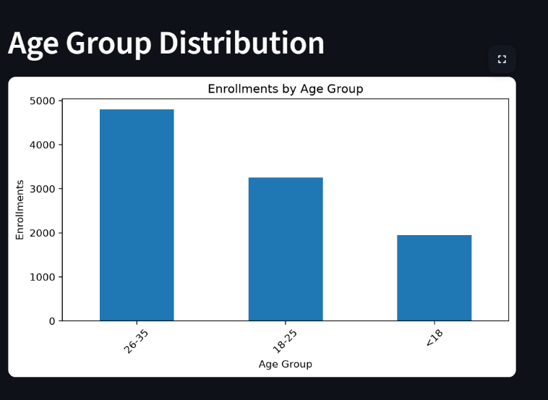
Fig. 4.1. Age Group Distribution of Learner Enrollments on the EduPro Platform.

Figure 1 illustrates the distribution of learner enrollments across different age groups on the EduPro platform. The findings indicate that the 26–35 years age group recorded the highest number of enrollments, with approximately 4,800 enrollments, demonstrating strong engagement among young professionals and individuals seeking career advancement opportunities. The 18–25 years category represented the second-largest learner segment, accounting for nearly 3,300 enrollments, which reflects the growing adoption of online learning among students and early-career individuals. In contrast, learners below the age of 18 contributed approximately 1,900 enrollments, indicating comparatively lower participation among younger users. These findings suggest that EduPro primarily attracts adult learners who are motivated by skill development, professional growth, and lifelong learning objectives.
    - Results and Discussion
The age-based enrollment analysis reveals that the EduPro platform is predominantly utilized by learners within the working-age population. The high participation observed among individuals aged 26–35 years suggests that online learning platforms are increasingly being adopted for professional upskilling and continuous education. Educational planners may consider designing specialized programs tailored to the needs of this demographic while also developing initiatives to improve engagement among younger learners.

  - Gender Distribution
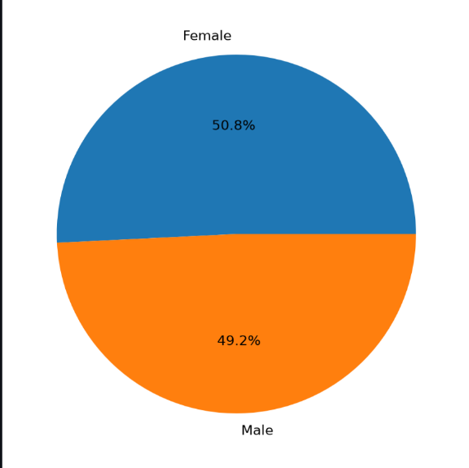
Fig. 4.2. Gender Distribution of Learners on the EduPro Platform.
Figure 2 presents the gender-wise distribution of learners enrolled on the EduPro platform. The analysis reveals a nearly balanced representation of male and female participants. Female learners account for approximately 50.8% of total enrollments, while male learners constitute around 49.2%. The minimal difference between the two groups indicates that the platform successfully attracts learners irrespective of gender. Such balanced participation reflects the growing acceptance of online learning among diverse populations and demonstrates the potential of digital education to provide equitable learning opportunities.

    - Results and Discussion
The gender distribution analysis suggests that EduPro promotes an inclusive learning environment with almost equal participation from male and female learners. Unlike traditional educational settings where gender disparities may influence access and participation, the findings indicate that online learning platforms can help reduce such barriers. The slight predominance of female learners may reflect increasing interest among women in pursuing skill development, career advancement, and lifelong learning through flexible digital platforms.
These findings emphasize the importance of maintaining gender-neutral educational strategies and ensuring that course offerings continue to address the interests and requirements of all learner groups.
    - Key Finding
- Female learners represented the largest share of enrollments (50.8%).
- Male learners accounted for 49.2% of enrollments.
- The difference between the two groups was minimal (1.6 percentage points).
- The results demonstrate strong gender inclusivity within the EduPro learning ecosystem.
    - Recommendation
- Educational planners and platform administrators should continue promoting equal access to learning opportunities and develop programs that encourage participation across all demographic groups. Regular monitoring of gender-based enrollment trends can further support inclusive educational practices and ensure that the platform remains accessible and relevant to diverse learner populations.

  - Course Category Popularity
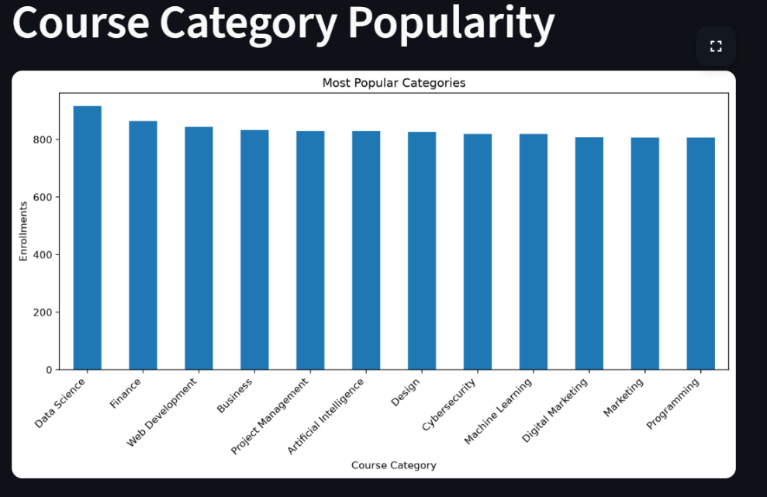
Fig. 4.3. Course Category Popularity on the EduPro Platform

Figure 3 illustrates the popularity of different course categories based on learner enrollments on the EduPro platform. The analysis shows that Data Science is the most popular category, recording the highest number of enrollments among all courses. Other highly preferred categories include Finance, Web Development, and Business, which also attract a substantial number of learners. While categories such as Marketing, Programming, and Digital Marketing have slightly lower enrollment figures, the differences across categories are relatively small. This indicates that learners have diverse interests and actively participate in a wide range of educational fields offered by the platform.
    - Results and Discussion
The course category popularity analysis reveals a strong demand for technology-oriented and career-focused courses. Data Science emerged as the leading category, reflecting the growing importance of data analytics, artificial intelligence, and data-driven decision-making across industries. The high enrollment in Finance and Web Development courses suggests that learners are actively seeking skills that improve employability and support career growth.
The relatively balanced enrollment levels across all categories indicate that EduPro successfully caters to diverse learner interests. Unlike platforms where a few subjects dominate participation, the findings suggest that learners are exploring multiple disciplines, including business, design, cybersecurity, and marketing. This diversity enhances the platform's ability to attract a broad audience and maintain sustained engagement
    - Key Findings
- Data Science recorded the highest number of enrollments, making it the most popular course category.
- Finance and Web Development ranked among the top-performing categories.
- Business, Artificial Intelligence, and Project Management also showed strong learner interest.
- Marketing and Programming categories had slightly lower enrollments but remained highly popular.
- Enrollment differences among categories were relatively small, indicating balanced learner preferences.
- The results demonstrate strong demand for both technical and professional development courses.
    - Recommendation

EduPro should continue investing in high-demand categories such as Data Science, Finance, and Web Development by expanding course offerings and introducing advanced learning paths. At the same time, the platform should maintain support for other categories to ensure a diverse educational portfolio. Regular analysis of enrollment trends can help identify emerging learner interests and guide future course development strategies. Additionally, targeted marketing campaigns can be used to promote less-enrolled categories and encourage balanced participation across all subject areas.

  - Course Level Distribution
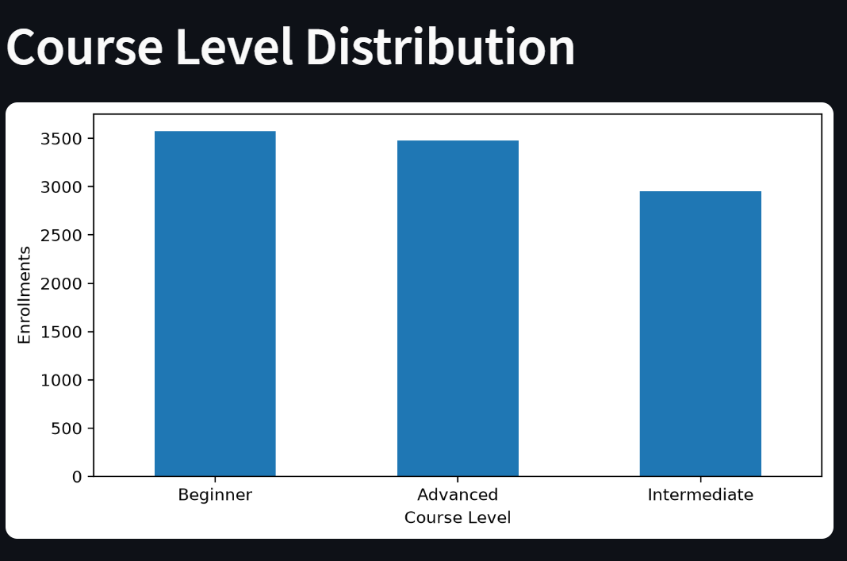
Fig. 4.4. Course Level Distribution on the EduPro Platform
Let's take a look at the courses on the EduPro platform. We can see how many learners are signing up for each level. It turns out that the most popular ones are the Beginner courses, which is great for people just starting out. Not far behind are the Advanced courses, which shows that many learners are also looking to take their skills to the next level. The Intermediate courses, on the other hand, don't seem to be as popular, but they're still an important part of the learning journey. What this tells us is that learners are really interested in either getting started with something new or becoming experts in a particular area. This is good news for the platform, as it means they can cater to people with different backgrounds and skill levels. By offering a range of courses, they can help learners achieve their goals, whether that's just starting out or advancing their careers. The fact that so many learners are signing up for Beginner and Advanced courses suggests that the platform is doing something right, and that learners are finding the courses they need to succeed.
    - Results and Discussion
The course level distribution analysis reveals a strong preference for Beginner-level courses, indicating that many learners join the platform to acquire foundational knowledge and develop new skills. The substantial enrollment in Advanced-level courses demonstrates that a significant proportion of learners are also interested in specialized knowledge and professional skill enhancement.
In contrast, Intermediate-level courses attracted relatively fewer enrollments. This trend may suggest that learners often prefer entering at the beginner stage or directly pursuing advanced content based on their prior experience and career objectives. The findings reflect the diverse learning needs of users and emphasize the importance of providing educational content across multiple competency levels.

4.4.2 Key Findings
- Beginner-level courses recorded the highest enrollment among all course levels.
- High-level classes were really popular and came in second, with a lot of students wanting to take them.
- Intermediate-level courses received the lowest enrollment among the three categories.
- The difference between Beginner and Advanced enrollments was relatively small.
- Learners demonstrated interest in both foundational and specialized skill development.
- The platform successfully caters to users with different knowledge and experience levels.
4.4.3 Recommendation
EduPro needs to keep adding more courses for beginners, because a lot of new learners are joining the platform. At the same time, they should make the advanced courses better by adding special content, certifications, and learning paths that are focused on specific industries, so they can meet the needs of learners who already have some experience. To get more people to take the intermediate courses, the platform could create a clear path for learners to follow, give them personalized suggestions, and reward them for progressing from beginner to intermediate levels. If they keep an eye on how many people are enrolling in each course, they can make sure they're developing the right courses and that all levels are growing at a good pace. This way, EduPro can support learners at every stage, from beginners to advanced, and help them achieve their goals. By doing this, EduPro can make sure that learners have a great experience and keep coming back to the platform to learn more.
  - Age Group vs Course Category Heatmap
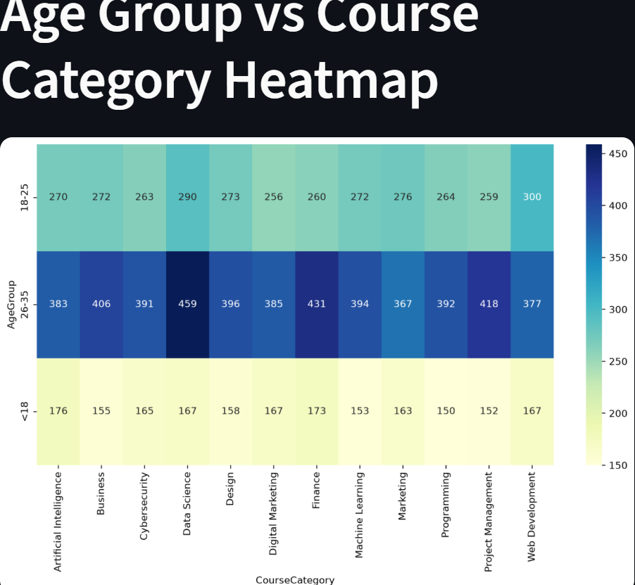
Fig. 4.5. Age Group versus Course Category Enrollment Heatmap on the EduPro Platform
Figure 5 presents a heatmap illustrating the relationship between learner age groups and course category enrollments on the EduPro platform. The analysis compares three age groups (<18 years, 18–25 years, and 26–35 years) across multiple course categories. The heatmap indicates that learners aged 26–35 years consistently recorded the highest enrollment levels across nearly all categories. Among these learners, Data Science achieved the highest enrollment count, followed by Finance and Project Management. Learners in the 18–25 years age group also showed strong participation, particularly in Web Development and Data Science courses. In contrast, learners aged below 18 years demonstrated comparatively lower enrollment levels across all categories.
The varying color intensities highlight differences in course preferences among age groups and provide insights into learner behavior across the platform.
    - Results and Discussion
When we look at the people using the EduPro platform, we can see that the ones between 26 and 35 years old are the most active. They are really interested in courses like Data Science, Finance, Business, and Project Management. This shows that they want to move forward in their careers, learn new things, and get skills that are useful in their industries. This makes sense because people who are already working want to improve their qualifications and stay competitive in the job market. They want to keep learning and growing so they can do better in their jobs.
The 18–25 years age group also exhibited significant engagement, particularly in technology-oriented fields such as Web Development, Data Science, and Marketing. This reflects the growing interest among students and early-career professionals in developing technical competencies and employability skills.
Young people under 18 are not signing up as much as other age groups. But even though not many are joining, they are still interested in lots of different things. This could be a good chance to create programs that are just for young people, and maybe get more of them to join in the future.
The results show that age is a big factor in what courses people choose and whether they enroll. It seems that people who are already working and have some experience are the ones who are using the platform the most.
    - Key Findings
- People learning between the ages of 26 and 35 signed up for the most courses in every category.
- People between 26 and 35 years old really liked taking Data Science courses, and more of them signed up for these classes than any other type.
- Learners aged 18–25 years showed strong interest in Web Development, Data Science, and Marketing courses.
- Young people under 18 had the fewest students enrolled in all areas.
- Technology-focused courses attracted high participation across all age groups.
- The age of learners had a big impact on what they liked and how they used the platform. It also affected the courses they chose to take.

    - Recommendation
EduPro needs to keep making courses that are advanced and focused on careers to help learners who are 26 to 35 years old and really engaged. For the 18 to 25 age group, they should add more programs that teach technology, entrepreneurship, and skills to help with school and career. To get more younger learners involved, EduPro should make courses that are easy to start with, have interactive ways of learning, and have content that's suitable for their age. By regularly looking at how many people from different age groups are signing up, EduPro can make learning paths that are tailored to each group and make learning more engaging for everyone. This way, they can make sure that all learners, no matter how old they are, have a great experience and get the most out of the platform.
- Dashboard Development
5.1 Dashboard Overview
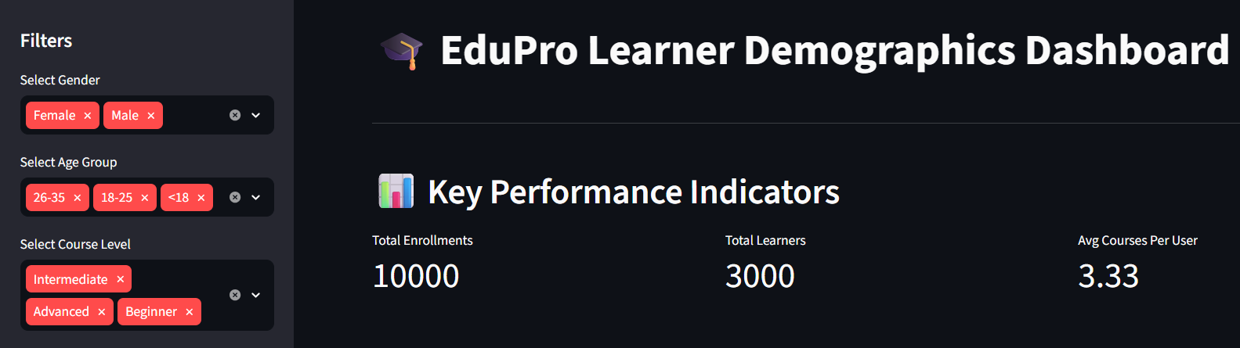
Fig. 5.1. Interactive EduPro Learner Demographics Dashboard
The EduPro Learner Demographics Dashboard was developed to transform raw educational data into meaningful visual insights. Interactive filters were implemented to allow users to analyze learner behavior across different demographic segments. KPI cards were incorporated to summarize important platform statistics and support quick decision-making.
The dashboard is designed to help people in charge of education make informed decisions by bringing together important information, tools to filter that information, and key performance indicators all in one place. This makes it easier for them to keep an eye on how learners are participating, see how well the platform is working, and spot patterns in the way people are learning. By doing this, the dashboard helps administrators and stakeholders get a clearer picture of what's going on and make better choices to support learners.
    - Outcome
The new dashboard is really good at helping us understand who our learners are and how they're doing. It's got interactive filters and key performance indicators that make it easy to get the information we need. This makes it a great tool for making smart decisions about education and managing our platform. With this dashboard, we can quickly see important information and use it to plan for the future. It's a big help in making sure our learners have the best experience possible.

  - Interactive Filters
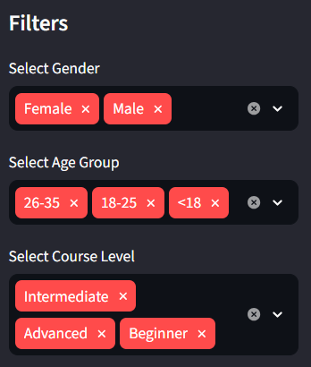
Fig. 5.2. Sidebar Filters for Learner Demographics Analysis

Figure 7 illustrates the sidebar filtering functionality integrated into the EduPro Learner Demographics Dashboard. The filter panel enables users to dynamically analyze and explore learner data based on three key dimensions: Gender, Age Group, and Course Level. Users can select one or multiple values within each category, allowing customized analysis of learner demographics and enrollment patterns.
You can look at the data in different ways using the filters. For example, you can choose to see information about male or female learners. The age filter lets you pick from three groups: people under 18, those between 18 and 25, and those between 26 and 35. There's also a filter for the level of the course, so you can look at beginner, intermediate, or advanced courses separately. These filters make it easier to explore the data and get a better understanding of the different groups of learners. They give you more control over what you're looking at, which can be really helpful when you're trying to analyze the data and learn more about the learners.
    - Outcome
The implementation of interactive sidebar filters significantly enhances the flexibility and effectiveness of the EduPro dashboard. The feature allows stakeholders to perform targeted analysis of learner demographics and enrollment trends, leading to more informed educational planning and data-driven decision-making.
  - KPI Metrics
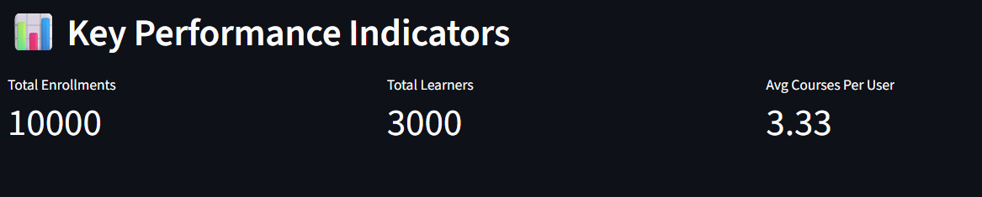
Fig. 5.3. Key Performance Indicators (KPIs) of the EduPro Learner Demographics Dashboard

Figure 8 presents the Key Performance Indicator (KPI) section of the EduPro Learner Demographics Dashboard. The KPI cards provide a concise summary of the platform's overall performance and learner engagement. Three primary metrics are displayed: Total Enrollments (10,000), Total Learners (3,000), and Average Courses per User (3.33).
These indicators help users see how many learners are taking part and how well the platform is working. The KPI section gives a quick overview, so administrators and stakeholders can check important metrics without having to look at a lot of detailed data. This makes it easy for them to keep an eye on things and make sure everything is running smoothly.
    - Outcome
The KPI section successfully summarizes key educational metrics in a clear and accessible format. By presenting enrollment and learner statistics at a glance, it enables stakeholders to evaluate platform performance efficiently and supports data-driven educational management.
5.4 Three-Dimensional Insight
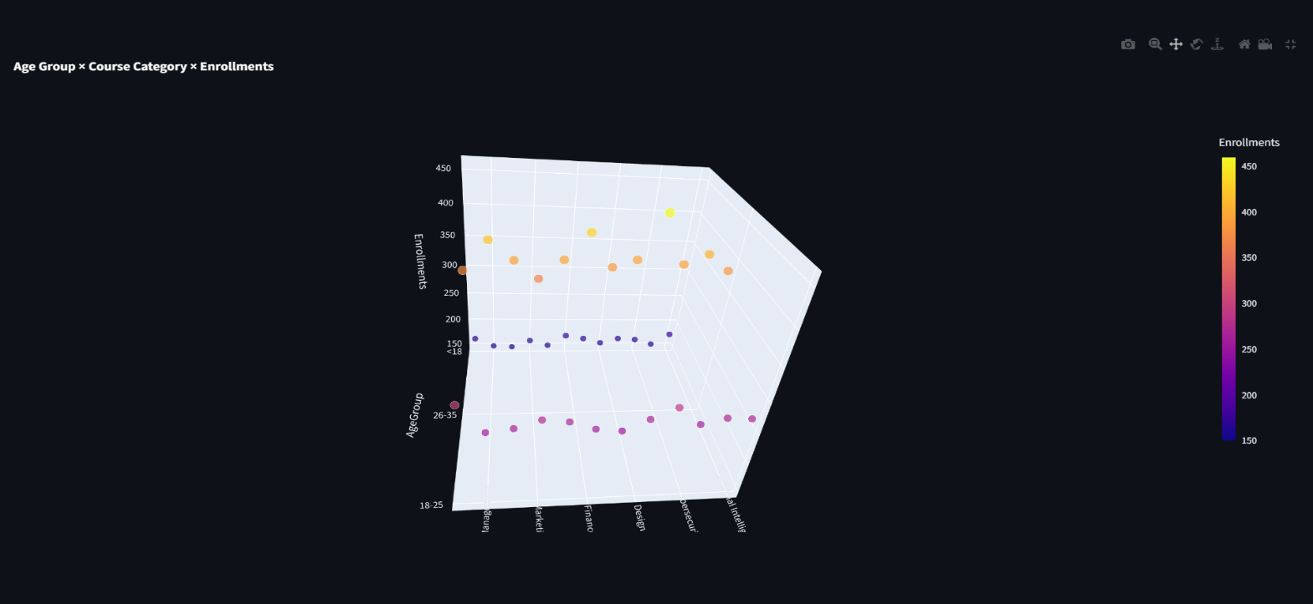
Fig. 5.1. 3D Scatter Plot of Age Group, Course Category, and Enrollments
Let's take a closer look at the relationship between age, course type, and enrollment numbers on the EduPro platform. Figure 9 shows us a 3D scatter plot that helps us understand how these factors are connected. We can see how different age groups interact with various course categories, and how enrollment numbers vary across these groups. The color scale is a useful tool here, as it gives us a sense of enrollment intensity - the brighter the color, the more people are enrolling in a particular course. On the other hand, darker colors indicate lower enrollment levels. By analyzing this data, we can gain insights into what courses are most popular among different age groups, and how we can tailor our offerings to meet the needs of our learners. This information can be really valuable in helping us create a more effective and engaging learning experience.
If we look at the numbers, we can see that people between 26 and 35 years old are signing up for courses more than any other age group. This is true for most types of courses, but it's especially clear for Data Science, Finance, and Project Management classes. Younger learners, those between 18 and 25, are also pretty active in taking courses. On the other hand, people under 18 aren't enrolling in as many courses as the other age groups. This trend is consistent across all the different types of courses that are available. It's interesting to think about what might be driving these patterns, and what it could mean for how we design and offer courses in the future.5.1.1
5.1.1 Outcome
The 3D scatter plot successfully provides a comprehensive view of learner enrollment behavior across demographic groups and course categories. The visualization helps administrators and decision-makers identify high-demand courses, understand age-based learning preferences, and support data-driven educational planning. By incorporating multidimensional analysis, the dashboard offers richer insights into learner engagement and platform performance.

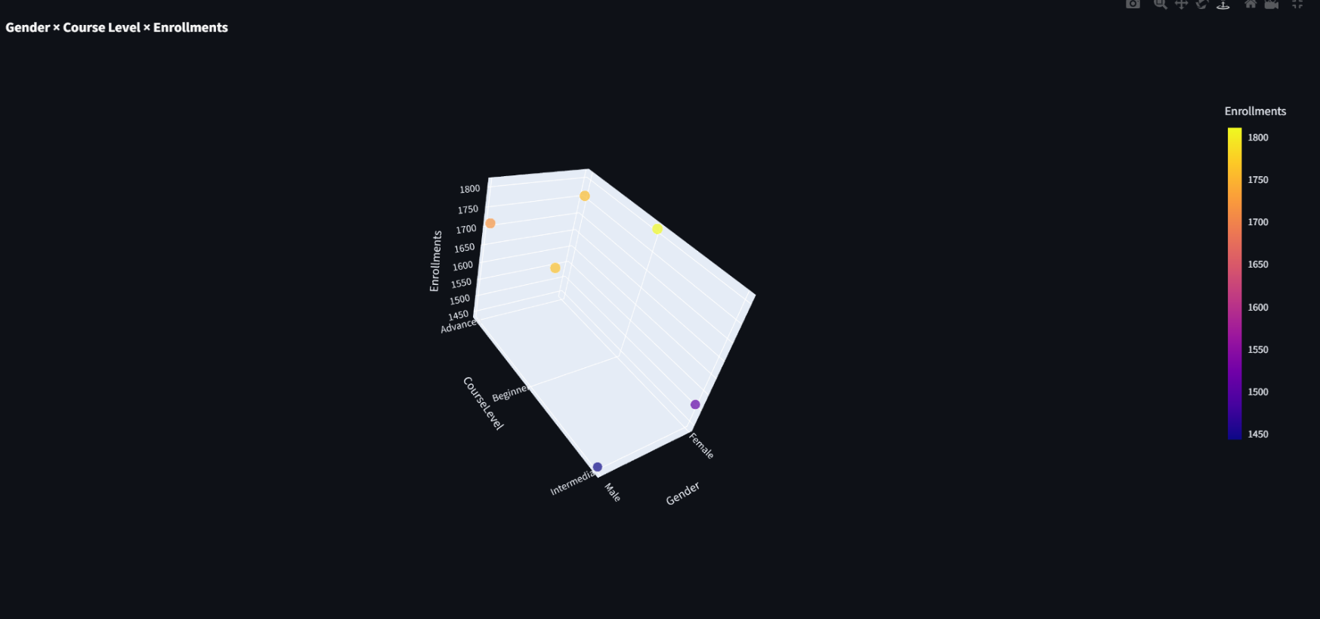
Fig. 5.2: Gender × Course Level × Enrollments
Figure 10 presents a three-dimensional scatter plot showing the relationship between Gender, Course Level, and Enrollment Count on the EduPro platform. The visualization illustrates how male and female learners are distributed across Beginner, Intermediate, and Advanced course levels. The color scale represents enrollment volume, with brighter colors indicating higher enrollment counts.
The plot reveals that Beginner-level courses recorded the highest enrollments for both male and female learners. Advanced-level courses also attracted substantial participation, while Intermediate-level courses showed comparatively lower enrollment counts. The enrollment patterns appear relatively similar across genders, indicating balanced participation and strong inclusivity within the platform

5.2.1 Outcome
The 3D scatter plot effectively highlights the relationship between learner gender and course level enrollments. The visualization demonstrates balanced participation among male and female learners while identifying Beginner-level courses as the most popular learning stage. By providing a comprehensive view of enrollment patterns, the chart supports data-driven educational planning and helps stakeholders better understand learner engagement across different course levels.
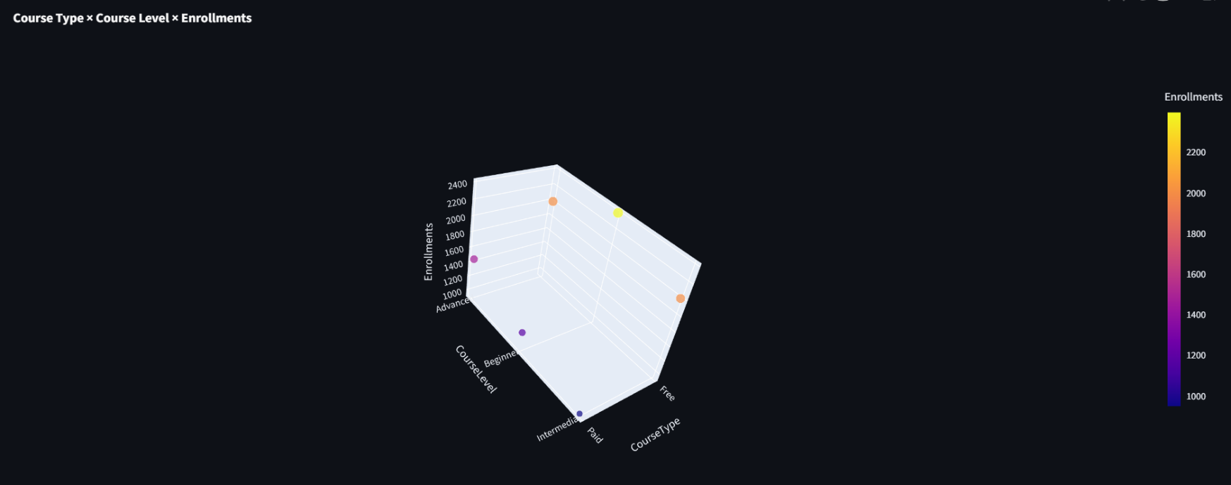
Fig. 5.3: Course Type × Course Level × Enrollments
Figure 11 presents a three-dimensional scatter plot illustrating the relationship between Course Type, Course Level, and Enrollment Count on the EduPro platform. The visualization compares learner enrollments in Free and Paid courses across Beginner, Intermediate, and Advanced learning levels. The color intensity of each marker represents the magnitude of enrollments, with brighter colors indicating higher enrollment volumes.
If you look at the numbers, you can see that free courses are way more popular than paid ones, no matter what level they're at. And when it comes to free courses, the ones that are for beginners are the most popular - people really want to learn the basics. Paid courses, on the other hand, don't get as many students, but they still do okay, especially the advanced ones. It seems like people are willing to pay for courses that will really challenge them and help them learn more complex things. So, overall, it's clear that people love free courses, but they're also willing to pay for quality education if it's going to help them achieve their goals.
5.3.1 Outcome
The visualization reveals that free courses generate the highest learner participation across all course levels, highlighting the importance of accessible educational content in attracting users. Beginner-level free courses emerged as the most popular category, suggesting that learners often prefer cost-free introductory learning opportunities. These insights can assist educational administrators in designing effective pricing strategies, improving course offerings, and increasing learner engagement on the EduPro platform.
6. Recommendations
Based on the findings obtained from the analysis of learner demographics and course enrollment behavior on the EduPro platform, the following recommendations are proposed:
6.1 Expand High-Demand Course Categories
The analysis identified that certain course categories attract significantly higher enrollments. EduPro should increase the availability of these popular courses by introducing advanced modules, specialized certifications, and updated content aligned with current industry requirements.
6.2 Strengthen Engagement Among Underrepresented Groups
Although the platform demonstrated inclusive participation, some demographic groups, particularly younger learners and older adults, exhibited relatively lower enrollment rates. Targeted awareness campaigns, age-specific learning pathways, and promotional initiatives can encourage greater participation from these groups.
6.3 Implement Personalized Learning Recommendations
Using learners' demographic profiles and enrollment histories, EduPro can develop personalized course recommendation systems. Such systems can assist learners in identifying relevant courses, thereby improving engagement and learning satisfaction.
6.4 Enhance Interactive Learning Experiences
Integrating interactive elements such as quizzes, discussion forums, peer collaboration, and gamification techniques may improve learner motivation and retention on the platform.
6.5 Promote Data-Driven Decision Making
Educational planners and administrators should continuously monitor enrollment trends and learner preferences using analytical dashboards. Regular evaluation of learner behavior will support evidence-based policy formulation and efficient resource allocation.
6.6 Improve Inclusivity and Accessibility
EduPro should continue ensuring equal access to educational opportunities by offering user-friendly interfaces, multilingual resources, and support mechanisms that accommodate diverse learner needs.

7. Conclusion
This study analyzed learner demographics and course enrollment behavior on the EduPro online learning platform using descriptive analytics techniques. By integrating user, course, and transaction datasets, meaningful insights were generated regarding learner characteristics, enrollment preferences, and participation patterns.
The findings revealed that learners belonging to the 26–35 age group constituted the largest segment of the platform's user base, indicating strong interest in online learning among working professionals and individuals seeking career advancement opportunities. Gender analysis demonstrated nearly equal participation between male and female learners, highlighting the inclusive nature of the EduPro platform.
Furthermore, the analysis identified variations in course preferences across demographic groups, emphasizing the importance of understanding learner behavior when designing educational offerings. Interactive visualizations, including bar charts, heatmaps, and three-dimensional insights, enabled effective exploration of these trends.
A Streamlit-based dashboard was successfully developed to provide stakeholders with an accessible and interactive decision-support tool. The dashboard allows dynamic filtering and visualization of learner data, facilitating informed educational planning and strategic decision-making.
The EduPro learner analytics framework shows how important it is to turn educational data into useful information. This study's results can help schools, platform administrators, and policymakers make learning more engaging, fair, and effective. To take this work further, future studies could use predictive analytics, recommendation systems, and advanced machine learning techniques to make online learning even better. By doing so, we can create a more personalized and responsive learning experience for students. This can lead to better outcomes and more opportunities for learners to succeed. Additionally, it can help identify areas where learners may need extra support, allowing for more targeted interventions. Overall, the potential of learner analytics to improve education is vast, and continued research in this area is crucial for creating a more effective and inclusive learning environment.

8. References
  - T. Anderson and J. Dron, "Three generations of distance education pedagogy," International Review of Research in Open and Distributed Learning, vol. 12, no. 3, pp. 80–97, 2011.
  - C. Romero and S. Ventura, "Educational data mining: A review of the state of the art," IEEE Transactions on Systems, Man, and Cybernetics, Part C: Applications and Reviews, vol. 40, no. 6, pp. 601–618, 2010.
  - G. Siemens and P. Long, "Penetrating the fog: Analytics in learning and education," EDUCAUSE Review, vol. 46, no. 5, pp. 30–40, 2011.
  - K. Jordan, "Initial trends in enrolment and completion of massive open online courses," International Review of Research in Open and Distributed Learning, vol. 15, no. 1, pp. 133–160, 2014.
  - S. Few, Information Dashboard Design: Displaying Data for At-a-Glance Monitoring, 2nd ed. Burlingame, CA, USA: Analytics Press, 2013.
  - UNESCO, "Education in a post-COVID world: Nine ideas for public action," UNESCO, Paris, France, 2020.
  - R. S. Baker and K. Yacef, "The state of educational data mining in 2009: A review and future visions," Journal of Educational Data Mining, vol. 1, no. 1, pp. 3–17, 2009.
  - R. Kizilcec, C. Piech, and E. Schneider, "Deconstructing disengagement: Analyzing learner subpopulations in massive open online courses," Proceedings of the Third International Conference on Learning Analytics and Knowledge, pp. 170–179, 2013.
  - Plotly Technologies Inc., "Plotly Python Open Source Graphing Library," Available: https://plotly.com/python/

